**Average Salary Expectations of Departments**

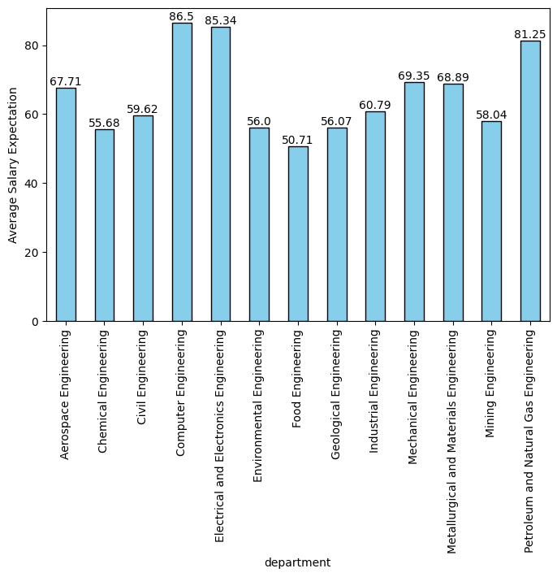

**General Conclusion**

Department choice significantly impacts salary expectations, with tech-related fields like Electrical and Electronics Engineering (86.5) and Computer Engineering (85.34) leading the way. These findings reflect industry demand and the perceived value of technical skills. Conversely, fields like Geological Engineering show lower expectations at 50.71, possibly due to limited opportunities. The variation across departments highlights the importance of aligning educational paths with industry trends and personal career goals. Students should consider both passion and market demand when choosing their field of study to ensure long-term career satisfaction and financial success. Career services and academic advisors can play a crucial role in guiding students to make informed decisions based on comprehensive market analysis and individual strengths.

**Average Salary Expectation by Gender**

metin, ekran görüntüsü, diyagram, dikdörtgen içeren bir resim

Açıklama otomatik olarak oluşturuldu

**General Conclusion**

The gender-based analysis highlights a persistent gap in salary expectations, with males expecting higher salaries at 69.86 compared to females at 64.67. This disparity may reflect societal norms, confidence levels, or awareness of gender pay gaps. The findings suggest that gender continues to influence financial expectations, pointing to the need for addressing gender inequality in career planning and salary negotiations. Encouraging equitable practices and fostering confidence in salary discussions could help bridge this gap. Institutions and employers should work towards creating an inclusive environment that supports equal opportunities and empowers all individuals to achieve their career and financial goals..

**Average Salary Expectation by Sector Preference**

metin, ekran görüntüsü, diyagram, dikdörtgen içeren bir resim

Açıklama otomatik olarak oluşturuldu

**General Conclusion**

The analysis of sector preference highlights a clear hierarchy in salary expectations, with academia leading at 91.21. This suggests that students perceive academic roles as offering the highest financial rewards, likely due to the prestige and potential for research funding and tenure. The private sector follows with expectations at 66.31, reflecting competitive salaries and performance-based incentives. The public sector, with the lowest expectations at 58.6, may be seen as offering stability but limited financial growth. Students who are unsure about their sector preference have expectations similar to the private sector at 66.3, indicating that uncertainty aligns with moderate expectations. Overall, sector preference plays a crucial role in shaping salary expectations, highlighting the importance of aligning career goals with perceived sector benefits. Students should consider both personal interests and market trends when choosing a sector to maximize their career satisfaction and financial outcomes.

**Average Salary Expectation by GPA**

metin, ekran görüntüsü, diyagram, paralel içeren bir resim

Açıklama otomatik olarak oluşturuldu

**General Conclusion**

GPA is a strong indicator of salary expectations, with higher GPAs correlating with higher expected salaries. Students with GPAs between 3.51-4.00 have the highest expectations at 85.85, reflecting confidence in their academic performance leading to better job offers. This trend underscores the value students place on academic excellence as a predictor of career success. The significant drop in expectations for GPAs below 3.0, such as 60.35 for 2.51-3.00, suggests a perceived threshold for competitiveness in the job market. Students without a GPA yet maintain moderate expectations at 71.63, indicating optimism based on other factors like internships or extracurricular achievements. Overall, GPA serves as a critical factor in shaping students' financial outlook, emphasizing the importance of academic achievement. Students should focus on maintaining strong academic records while also developing complementary skills to enhance their employability and salary prospects.

**Average Salary Expectation by Academic Year**

metin, ekran görüntüsü, diyagram, dikdörtgen içeren bir resim

Açıklama otomatik olarak oluşturuldu

**General Conclusion**

Salary expectations vary across academic years, with second-year students showing the highest optimism at 76.54. This may be due to early career planning and confidence in skill acquisition. First-year students also have high expectations at 71.09, reflecting initial enthusiasm and the belief in potential growth and learning opportunities. As students progress, expectations adjust, with fourth-year students at 66.28 and third-year students at 62.87, reflecting increased awareness of job market realities. The dip in third-year expectations suggests a critical period where students reassess their prospects. Overall, academic progression influences financial outlooks, emphasizing the need for continuous career planning and skill development throughout the academic journey. Institutions should provide resources and support to help students navigate these transitions and prepare effectively for their future careers.

**Average Salary Expectation by Country Preference**

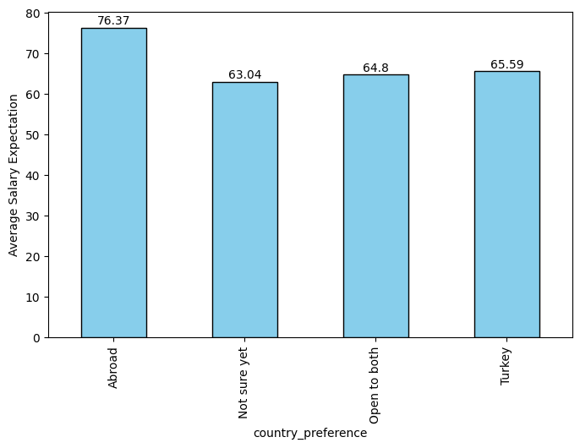

**General Conclusion**

Country preference plays a significant role in shaping salary expectations, with working abroad associated with the highest financial prospects at 76.37. This reflects perceptions of higher salaries and opportunities internationally. Students open to both local and international opportunities maintain moderate expectations at 64.8, indicating flexibility and a balanced approach. Those uncertain about their preference show lower expectations at 63.04, highlighting the impact of uncertainty on financial outlooks. Overall, country preference is a key factor in career planning, influencing both expectations and decision-making processes. Students should consider factors such as cultural fit, lifestyle, and long-term career goals when deciding on their preferred work location. Institutions can support students by providing information on global opportunities and facilitating international experiences to broaden their perspectives and enhance their employability.

**Average Salary Expectation by Field Preference**

metin, ekran görüntüsü, diyagram, dikdörtgen içeren bir resim

Açıklama otomatik olarak oluşturuldu

**General Conclusion**

The analysis of field preference reveals distinct differences in salary expectations based on alignment with one's academic department. Students who prefer to work within their department's field sector have the highest salary expectations at 70.43. This suggests confidence in their specialized skills and the perceived value of their education in securing well-paying jobs.

Those considering a different sector have slightly lower expectations at 63.67. This may reflect uncertainty about transferring skills to a new field or the potential need for additional training or qualifications.

Students who are not sure yet about their field preference have the lowest expectations at 61.65. This uncertainty might stem from a lack of clarity about career goals or the job market, leading to more conservative salary expectations.

Overall, field preference significantly influences salary expectations, highlighting the importance of aligning career paths with educational backgrounds and personal interests. Students should consider their strengths and market demands when making career decisions to optimize their financial prospects.